Wellness Center Ekso Indego Program
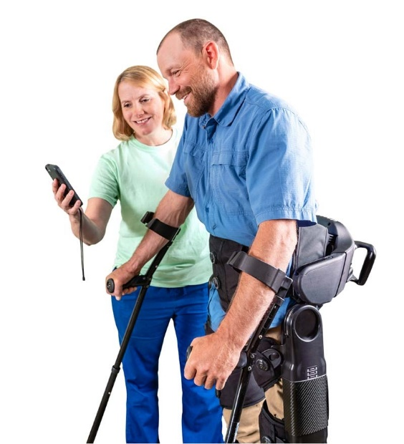

Wellness Center Ekso Indego Program check list:

- Ekso Indego Medical Waiver – requires evaluation and signature from your doctor.
- PT referral for technology evaluation for Ekso Indego – request from your doctor.
After you complete all the above steps, you are ready to schedule Wellness Center Ekso Indego Physical Therapy Evaluation.
For your appointments please complete the following:
- Sign up for Wellness Center membership (type of membership depends on your individual needs. Ekso Indego Physical Therapy evaluation and sessions cost additional fees).
- Bring both medical waiver and doctor referral to the reception.
- Schedule your appointment

***Wellness Center at Rancho does not take insurance. For personal use device training, clients are required to complete about 30 sessions. Physical Therapy price per session ranges from $110-$220***

